Daily Tip 84 27/11/2003 11:14:00 PM
Using Java & ActiveX to generate static graphs
In SAS 9 there are 2 new graphic devices that can be used to create graphs called actximg & javaimg. These produce very good looking graphics but are not interactive graphics, as their siblings are (ActiveX & Java). The files produced are actually in PNG format and by default will be 640x480 pixels (VGA). Try them out and see how easy it is to produce excellent looking output. The graph produced below was only 5.6kb in size.

Sample code
goptions device=actximg ;
/*goptions device=javaimg ;*/
ods html body='c:\test.html'
gpath='c:\'
(url=none) ;
proc gchart data=sashelp.shoes ;
vbar3d product / sumvar=sales ;
run ;
ods html close ;

Graph produced using ActXimg
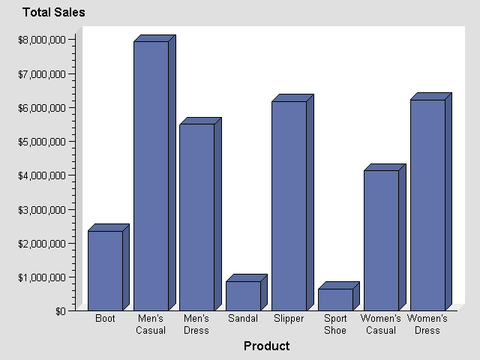Example tested under SAS 9.1, Windows XP by Phil Mason
Wood Street Consultants Ltd. tips@woodstreet.org.uk
www.woodstreet.org.uk
Instant Messengers … ICQ:27165944, AOL:philipamason, MSN: philipandrewmason@hotmail.com, Yahoo: philipandrewmasonb

